***Hypothesis Testing Exercise***

A F&B manager wants to determine whether there is any significant difference in the diameter of the cutlet between two units. A randomly selected sample of cutlets was collected from both units and measured? Analyze the data and draw inferences at 5% significance level. Please state the assumptions and tests that you carried out to check validity of the assumptions.

Minitab File: **Cutlets.mtw**

**Ans:** H0: There is no difference in the diameter of the cutlet between the two units.

H1: There is a difference in the diameter of the cutlet between the two units.

Using python,

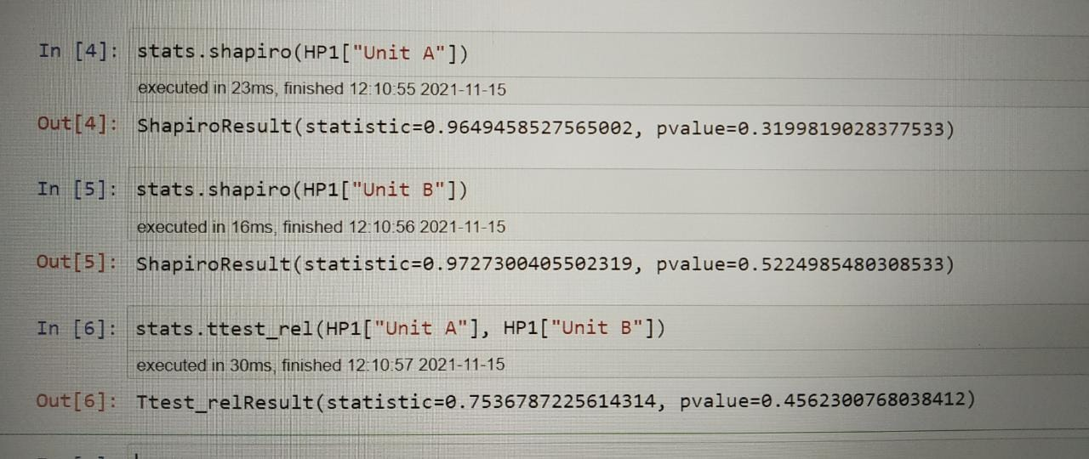

P-valve = 0.45

Since, p-value > 0.05(significance value), hence the null hypothesis(H0) is true.

A hospital wants to determine whether there is any difference in the average Turn Around Time (TAT) of reports of the laboratories on their preferred list. They collected a random sample and recorded TAT for reports of 4 laboratories. TAT is defined as sample collected to report dispatch.

Analyze the data and determine whether there is any difference in average TAT among the different laboratories at 5% significance level.

Minitab File: **LabTAT.mtw**

**Ans:**H0: There is no difference in the average TAT among the laboratories.

H1: There is a difference in the average TAT among the laboratories.

Using python,

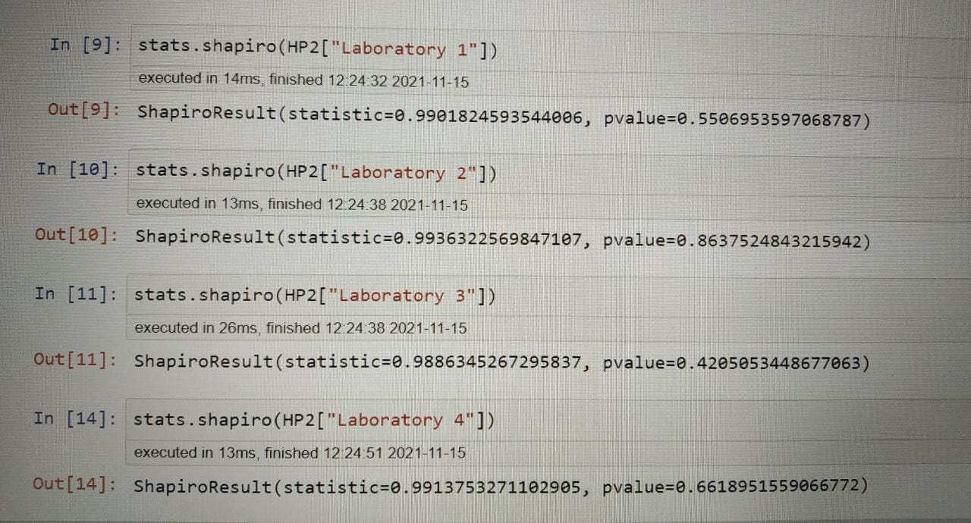

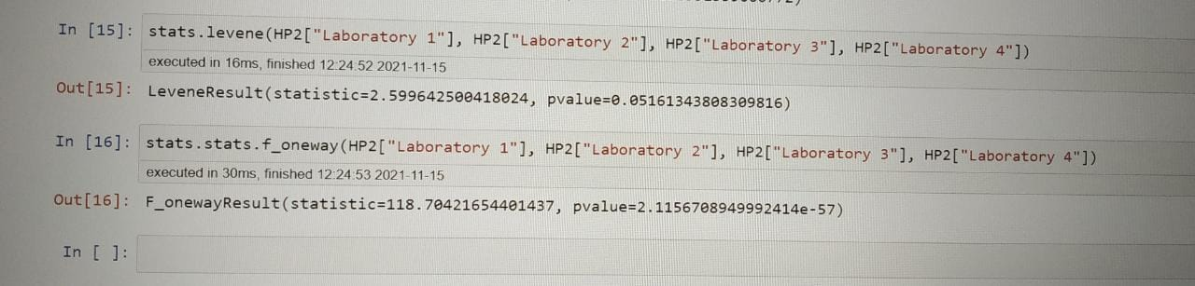

Since, the p-values are smaller

Then there is an average difference in TAT among the laboratories. Hence, alternate hypothesis is true.

Sales of products in four different regions is tabulated for males and females. Find if male-female buyer rations are similar across regions.

**Ans:** H0: The buyer ratio is similar.

H1: The buyer ratio is not similar.

Using python,

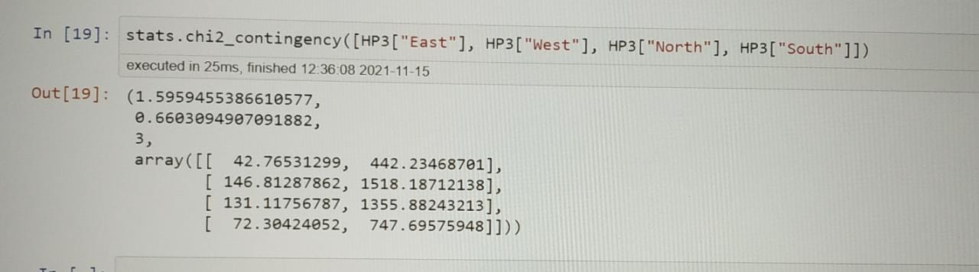

Since, p-value = 0.6, p-value > significance valve

Hence, the null hypothesis is accepted.

TeleCall uses 4 centers around the globe to process customer order forms. They audit a certain% of the customer order forms. Any error in order form renders it defective and has to be reworked before processing. The manager wants to check whether the defective% varies by centre. Please analyze the data at *5%* significance level and help the manager draw appropriate inferences

Minitab File: **CustomerOrderForm.mtw**

**Ans:** H0: The proportion of defective % across the center is same.

H1: The proportion of defective % across the center is not same.

Using python,

stats.chi2_contingency([HP4['Phillippines'].value_counts(), HP4['Indonesia'].value_counts(), HP4['Malta'].value_counts(), HP4['India'].value_counts()])

(3.8589606858203545, 0.2771020991233144, 3, array([[271.75, 28.25], [271.75, 28.25], [271.75, 28.25], [271.75, 28.25]]))

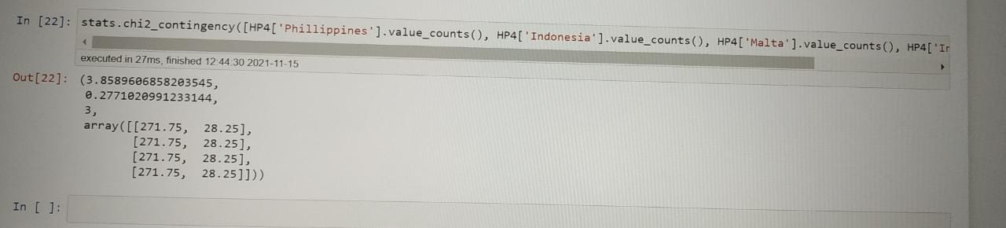

Since, p-value = 0.27, p-value > significance value

Hence, we accept the null hypothesis.